Making a resin Infused hard dodger

I like most boat owners have limited time and money so when boat projects arise I try to select solutions that are going to last. The dodger on my Tayana 37 which was only 12 years old was starting to fall apart. A season in Mexico and 11 years in the strong California sun had combined to rot both the fabric and the stitching on the top. The screen and sides which had been covered were still fine. It would seem that I could either replace the fabric dodger with another which would have the same problem in 10 years’ time or look at adding a hardtop to the dodger. Looking online I found Wavestopper and Tartarooga who both produce hardtop dodgers which look fantastic but are very expensive and so I looked at making one myself.

There are a number of sites detailing how people have made their own dodgers most of which seemed to be highly labor intensive with mixed results and never having done any fiberglass or molding I was somewhat skeptical as to my abilities to produce something that I would be happy with. At this point one of my friends Panda offered to help. Panda runs a rigging business here in Alameda and has done some molding of carbon fiber so knew a lot more than me. He suggested using a resin infusion method and it is this method that is described below.

So what is resin infusion and how is this different than other methods such as wet layup and vacuum bagging. To do a resin infusion you build a female mold the surface of which needs to be non-porous and high gloss. Around the perimeter of the molding you create a low wall using foam and clay. Then within the frame you place your layers of glass and foam using a contact adhesive to hold everything in place. Attach a vacuum bag over the top of the molding and when all the air is out let the resin in. The whole process is very clean and is relatively quick. The vacuum eliminates any bubbles of air in the gelcoat and because the resin is infused you get a totally wetted out product.

The pictures are below

Andy Signol
1987 Tayana 37 MK 11
andysignol@gmail.com
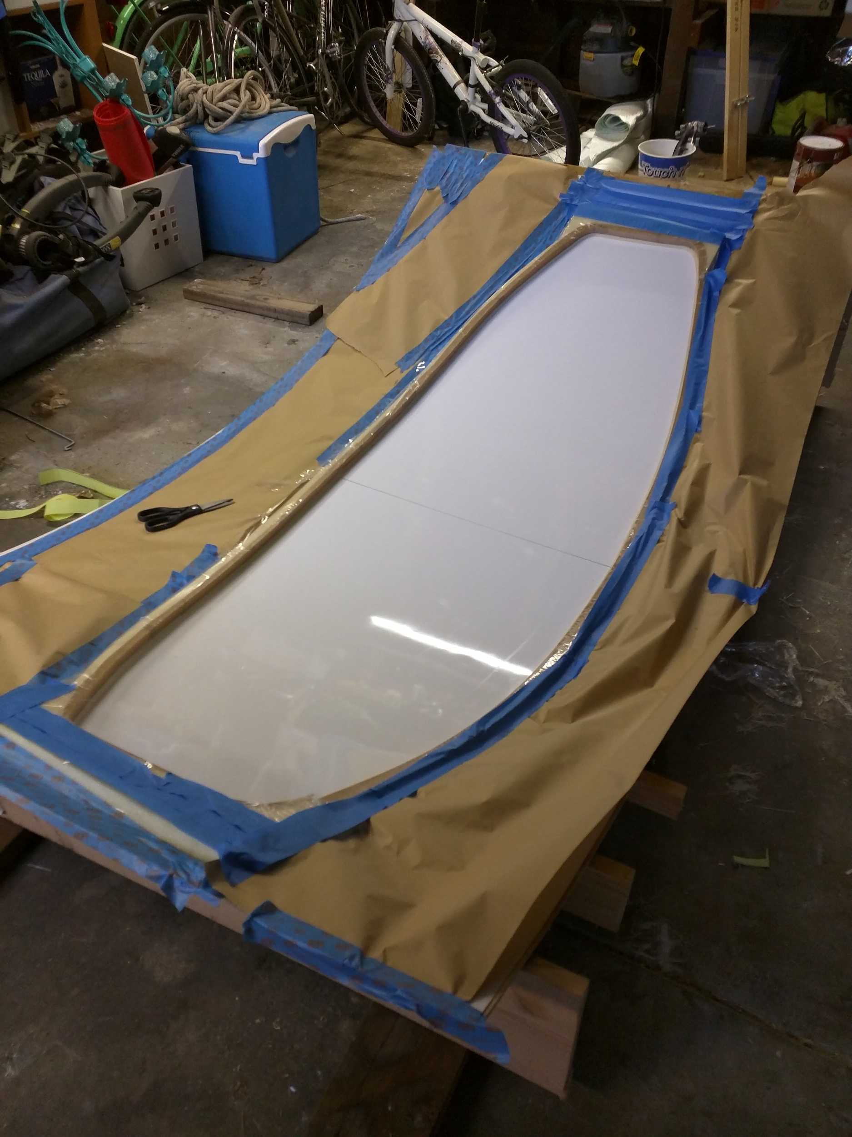
Mold
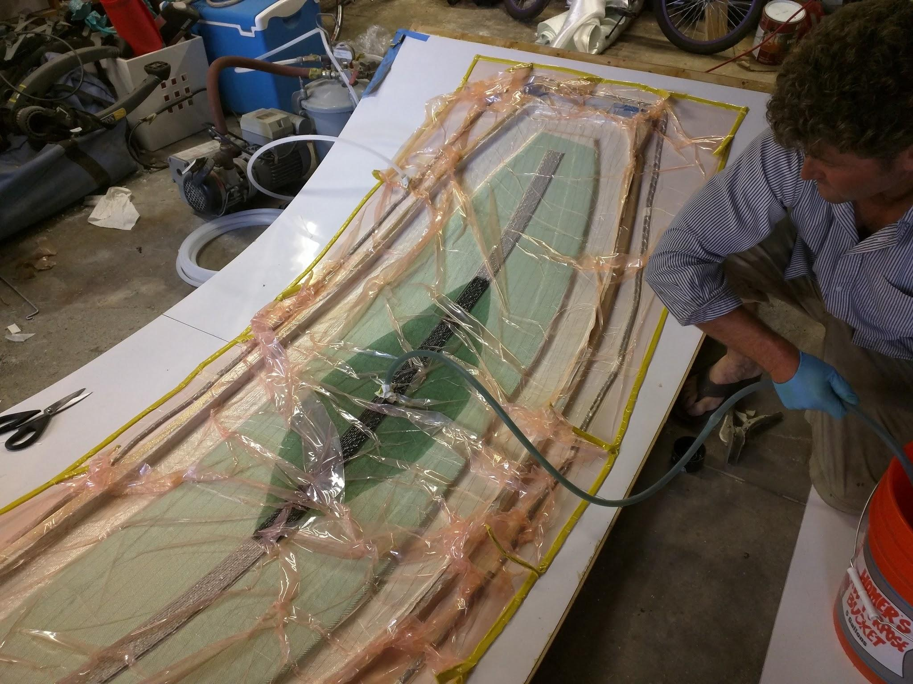
Resin being sucked into the layup
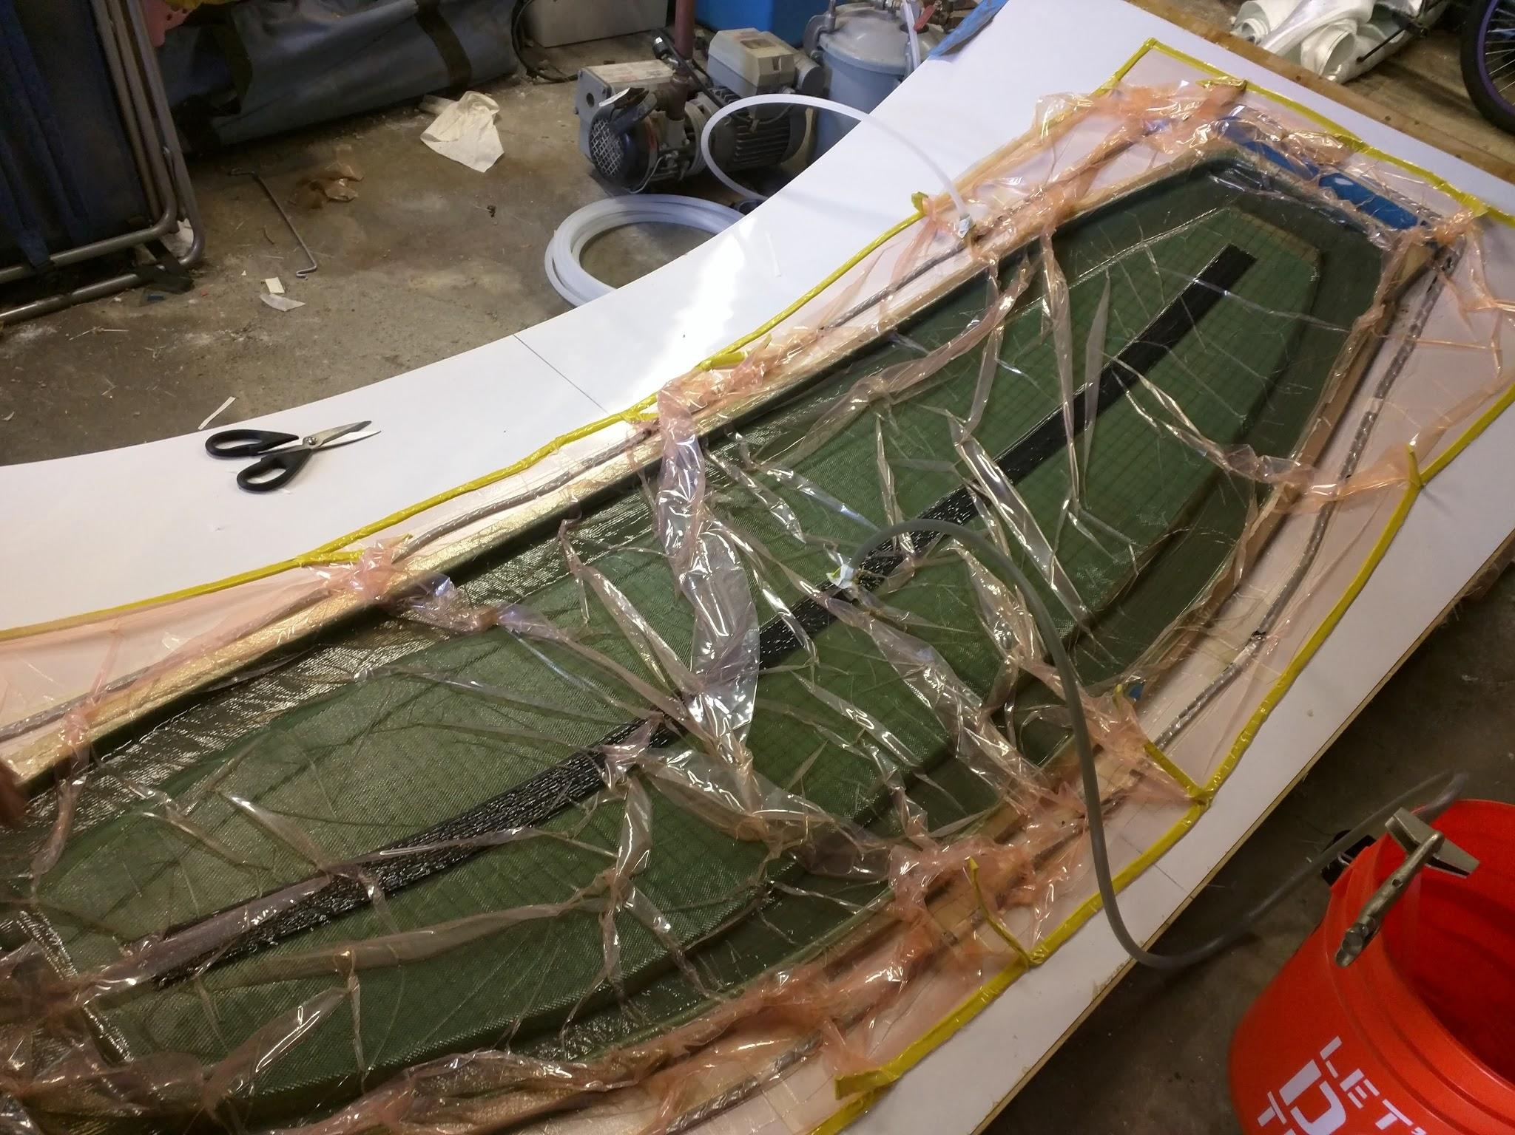
Complete infused glass
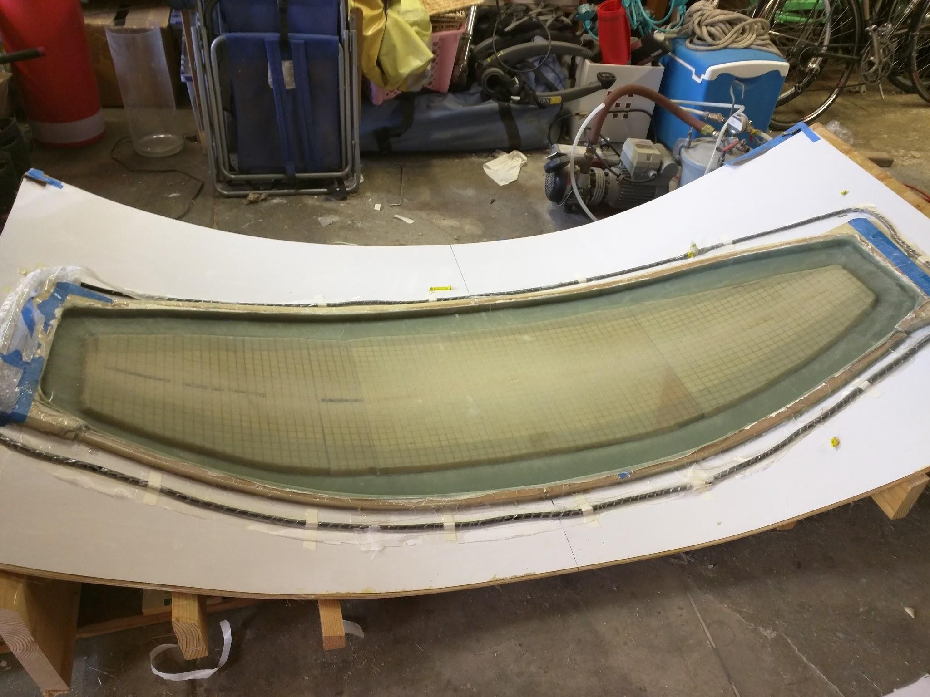
After vacuum bag is removed
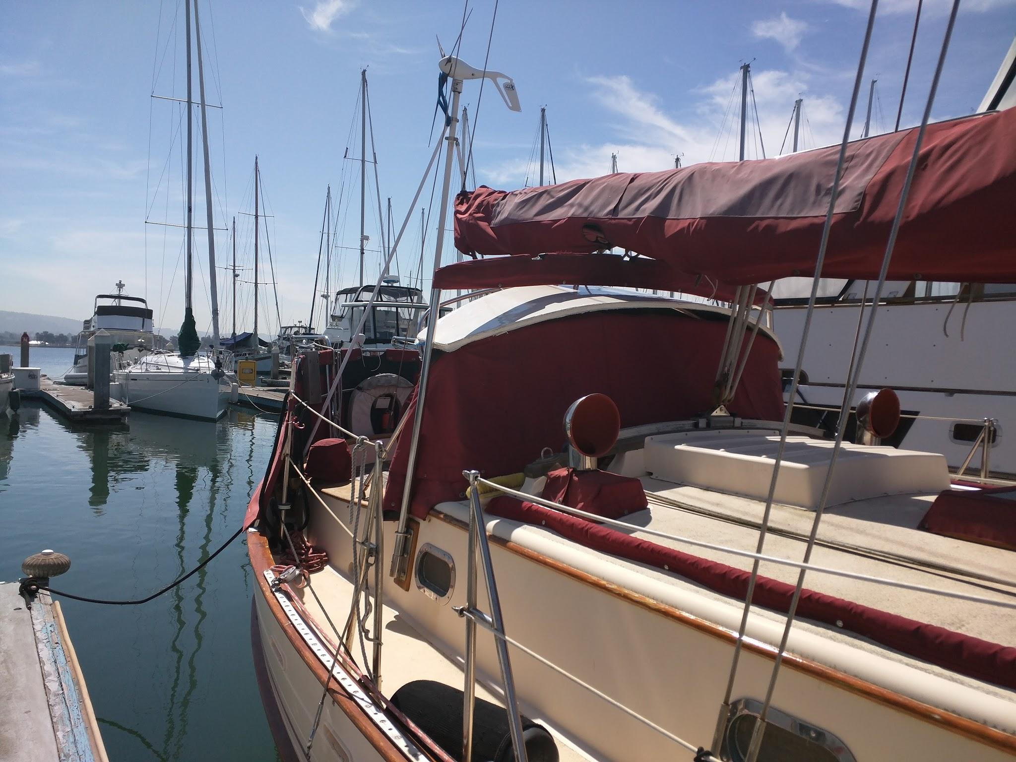
Trying it for fit
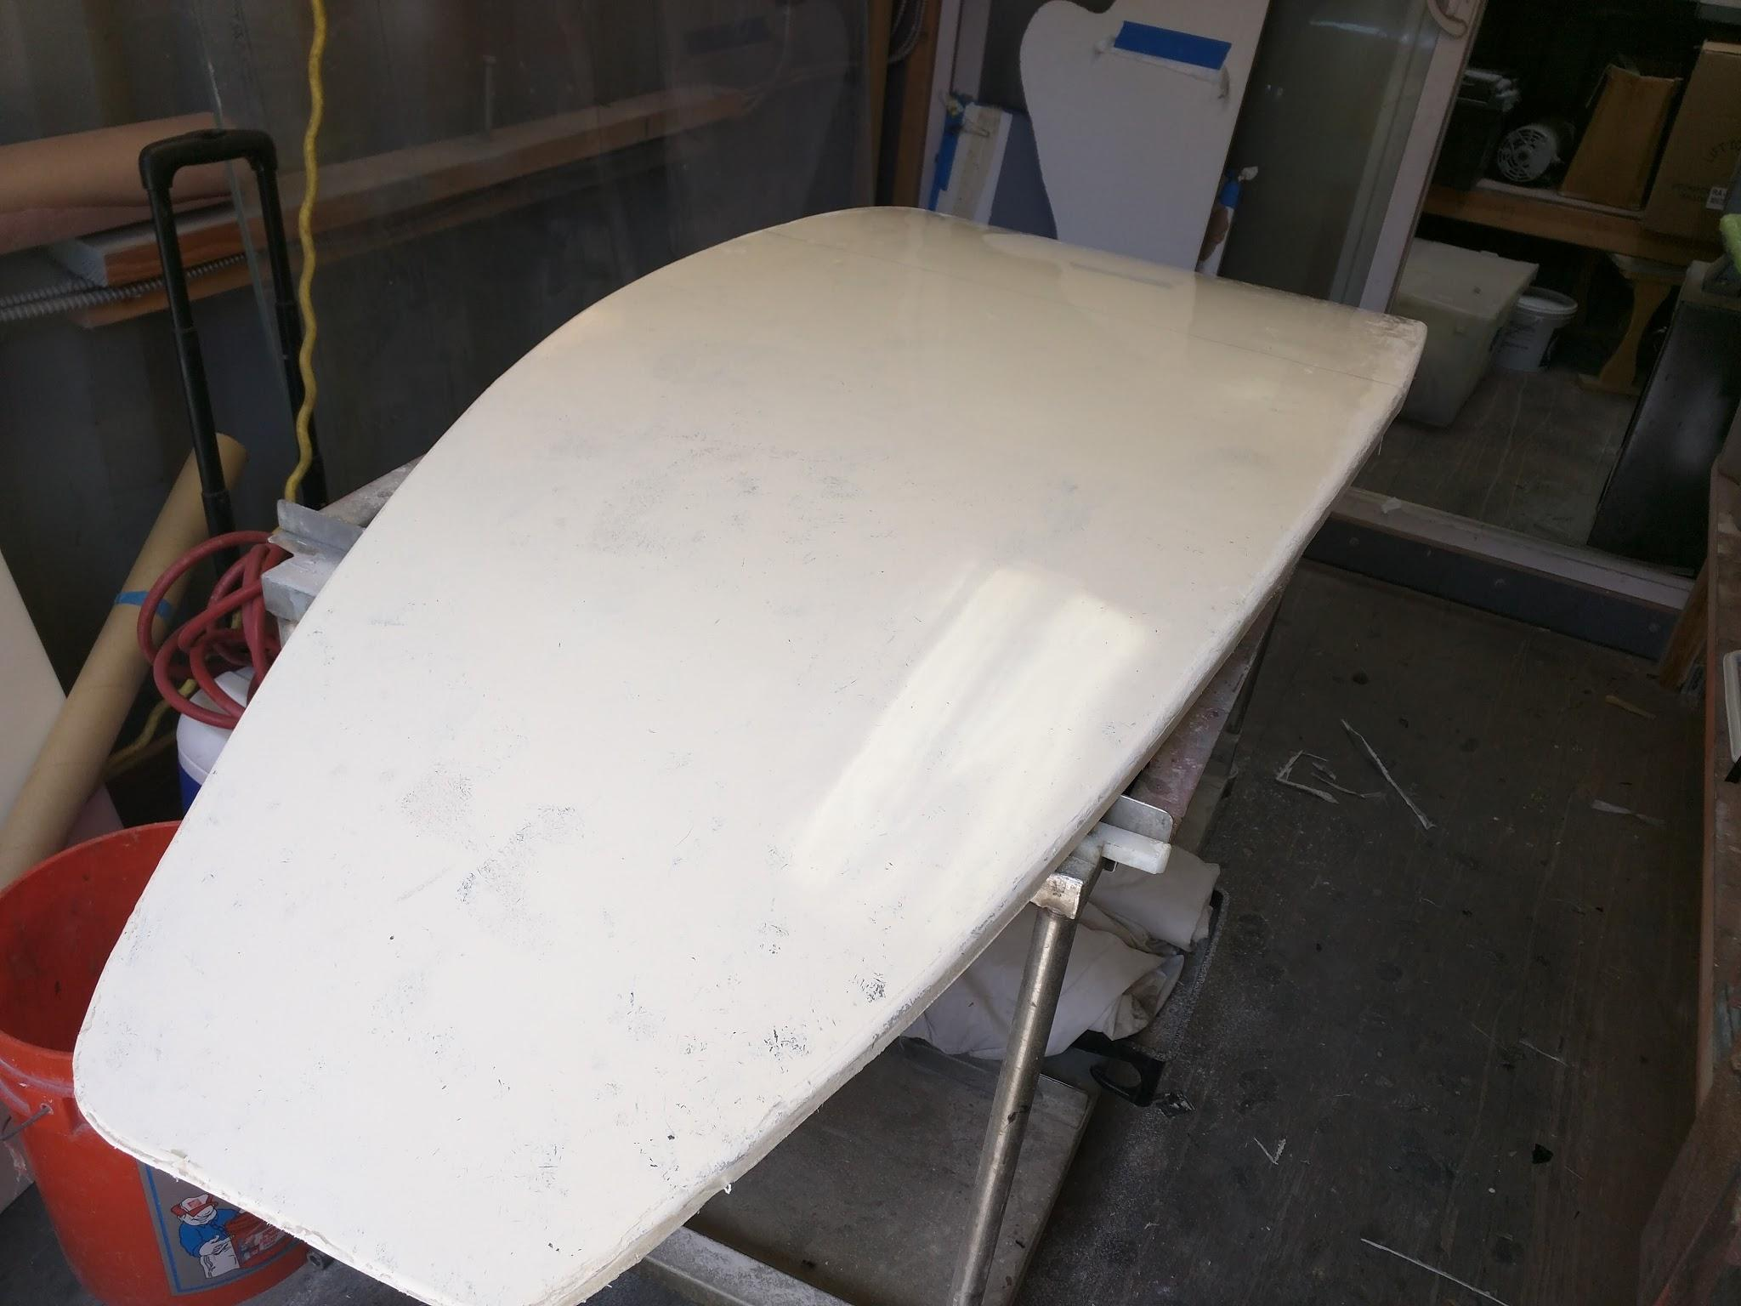
Before adding attachments
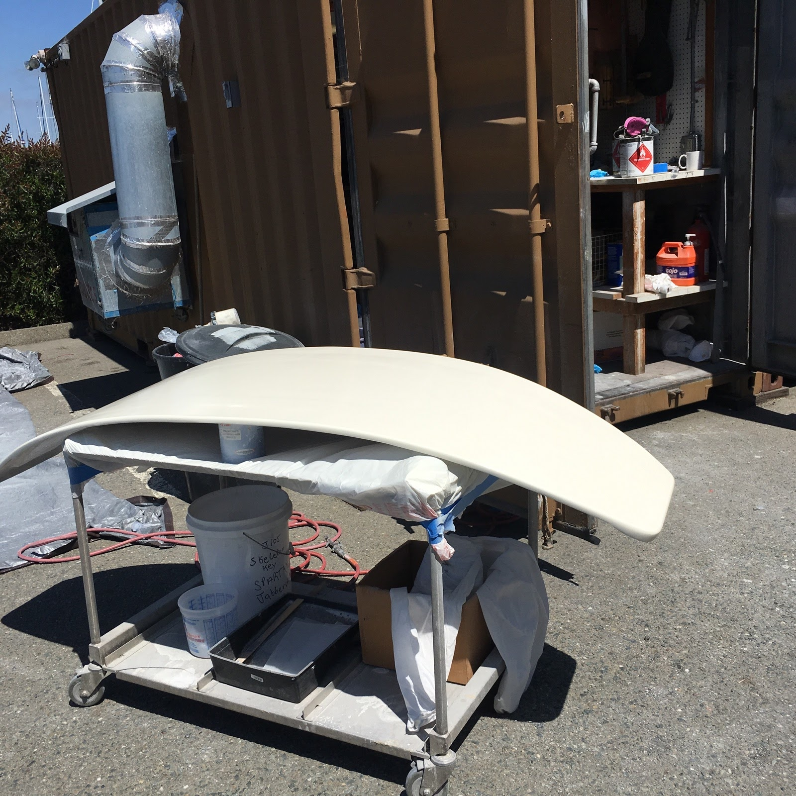
Before attaching flexirail and fittings.

